Cryptoarithmetic Puzzle

1)SEND+MORE=MONEY:

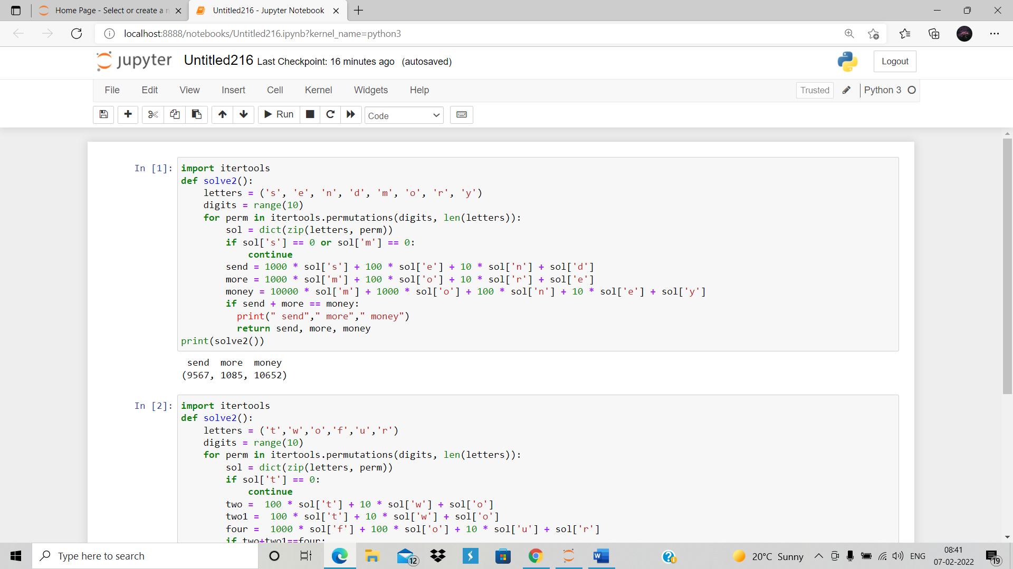

2)TWO+TWO=FOUR:

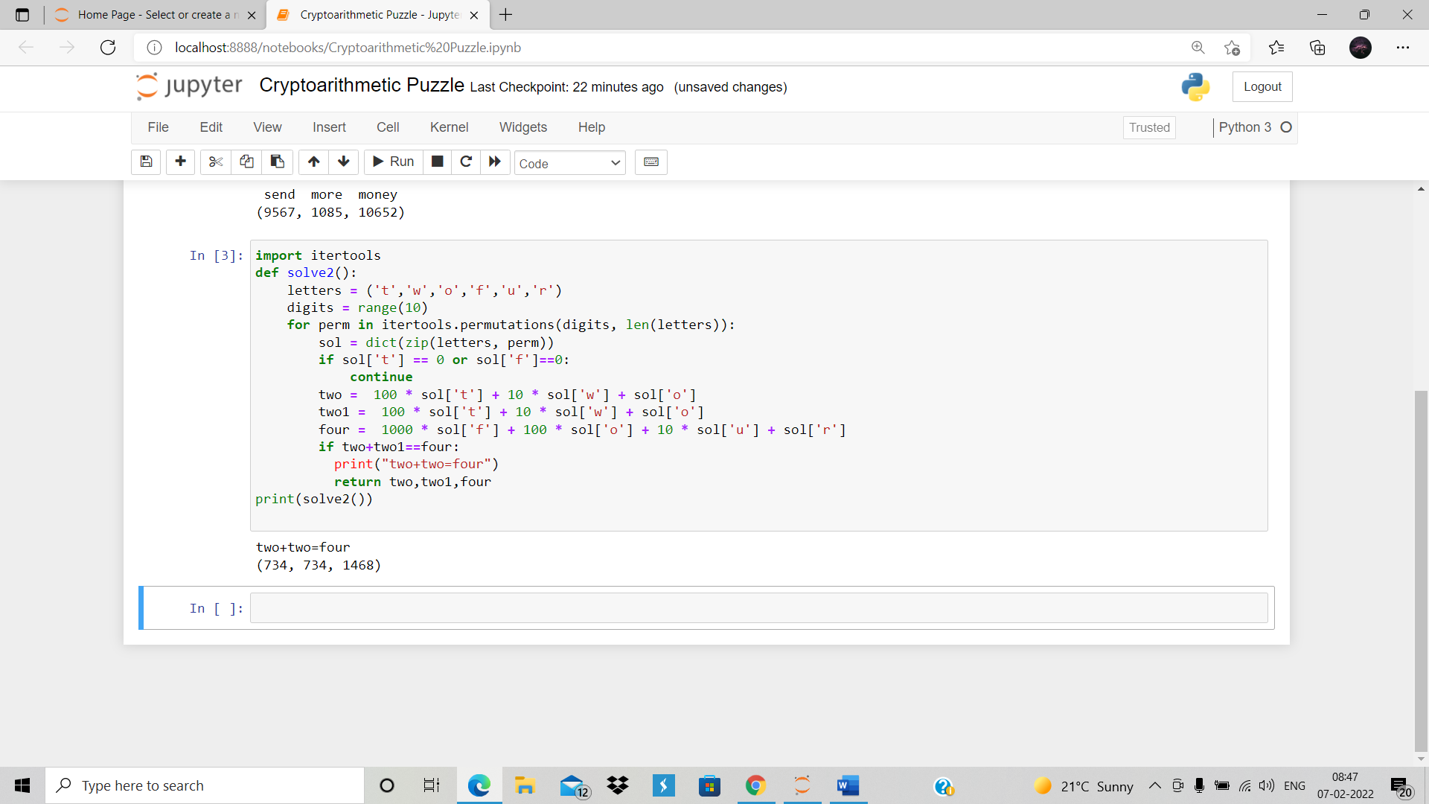

G.SRAVANI NEEHARIKA

(RA1911003010820)